Simulink diagram:
Fig-1.1: Simulink diagram of Transmission Lines Fault Detection using Wavelet in MATLAB.

Output:
Case-1:
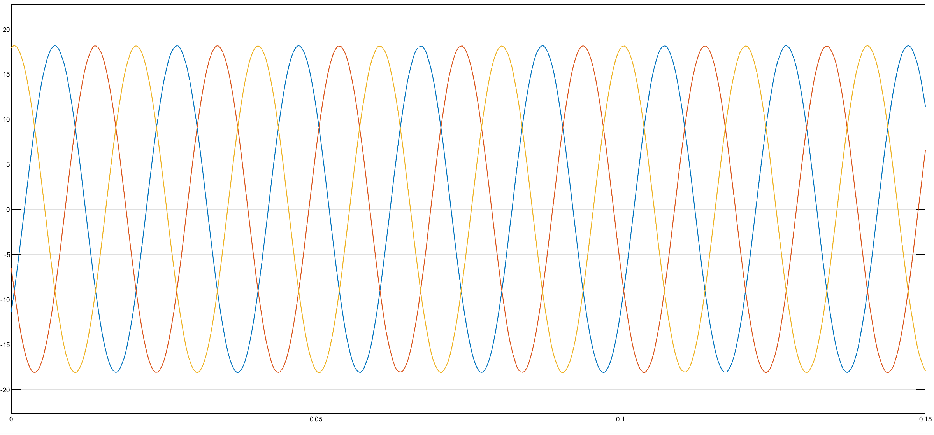
Fig-1.2: Simulation results of Transmission Lines Fault Detection using Wavelet without phase selection.

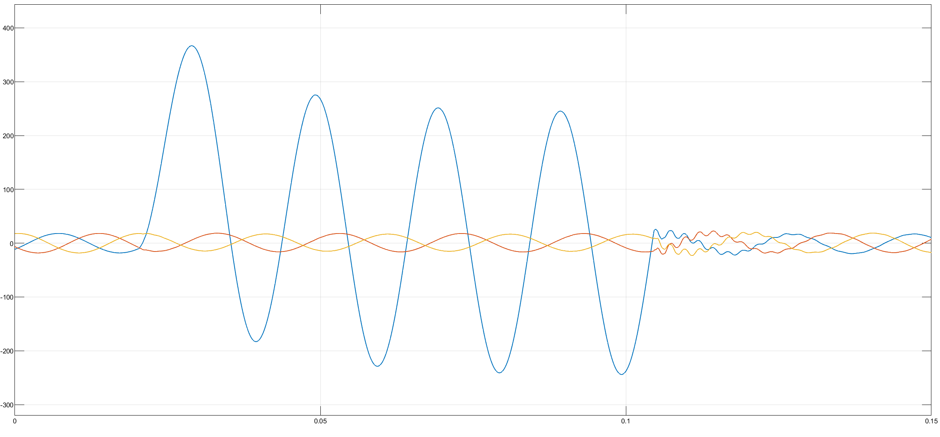
Case-2:
Fig-1.3: Simulation results of Transmission Lines Fault Detection Using Wavelet Transform for Phase A-to-Ground Fault.

